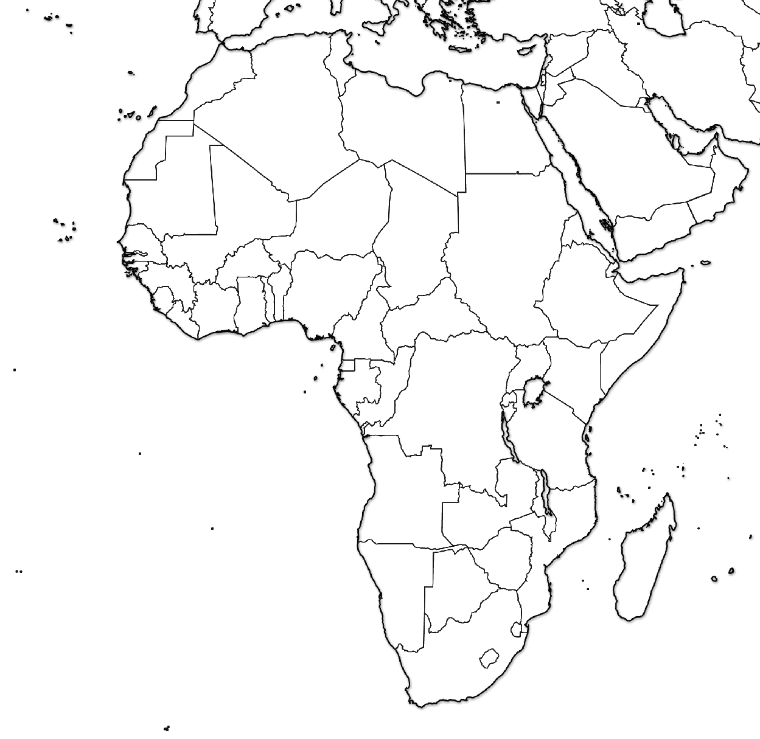

Results of the Berlin Conference (1884)

