Tsar’s autocracy

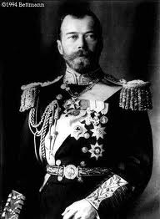

Tsar Nicholas II had absolute power over 125 million Russians. The Tsar could make new laws and raise taxes without consulting anyone. There was no parliament to limit his power.

The Russian Orthodox Church also supported the Tsar as the head of the Church.

Censorship and secret police

There was no freedom of the press.

The Tsar had secret police force, the ***Okhana***, who can arrest anyone who opposes him and exile people to Siberia without trial. The Tsar also had the **Cossacks**, his fierce mounted soldiers, who can break up any protest or butcher rebellious peasants with their sabers.

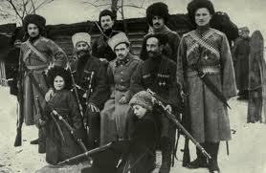

Nicholas and Alexandra’s public image

Nicholas was firm that he would not share any power, but he often seem to pay little attention to the details of ruling.

Nicholas and Alexandra were deeply in love. They were devastated that their only son, Alexis, had hemophilia, a blood disease that does not allow your blood to clot normally.

Because of Alexis’ hemophilia, they became intensely religious.

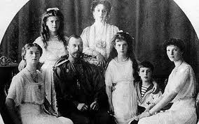

Deprivation for peasants

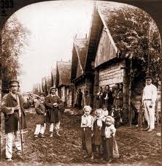

Russian peasants were free from serfdom in 1861, over 400 years after serfdom ended in the rest of Europe.

Taxes were high and in a bad harvest year, peasants might not be able to pay them. In a poor harvest, peasants might starve.

Nearly half of Russian children died of malnutrition before age five. Average life expectancy for adults was fifty years old.

Harsh working conditions in factories

Peasants who moved to the city to work were paid low wages for long hours of work.

Nearly one million Russians moved to St. Petersburg creating a housing shortage. People slept ten to a room. Plus peasants still needed to return to their farms during the harvest.

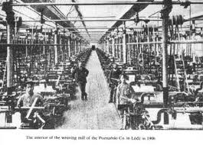

Excess of the aristocracy

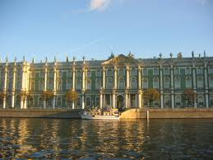 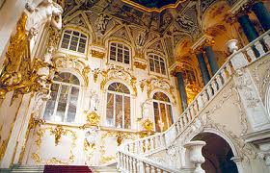

The aristocracy was 1% of the population, but owned 25% of the land. Capitalists, like American robber barons, earned tremendous profits from exploiting their workers.

The Tsar owned eight palaces and employed 15,000 servants.

Rasputin

Nicholas and Alexandra fell under the influence of a self-professed holy man, Gregory Rasputin. Rasputin told them he could cure their son’s hemophilia. His nickname meant “disreputable one.” He was said to have participated in orgies and to have once raped a nun. He had also given up bathing.

He began to give political advice to the Tsar and Tsarina. From August 1915 to December 1916, while Tsar Nicholas is at Eastern Front, Tsarina Alexandra and Rasputin run the government.

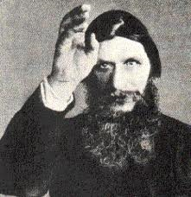

The First World War

Despite having the largest number of soldiers, the Russian army was ill-equipped to fight the Central Powers in 1914. Nearly one million soldiers had neither guns nor boots.

Food was in short supply because of inadequate railroads.

Russian soldiers suffered the highest casualties of any army.

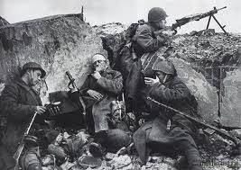

Inflation and shortages

Men left their farms and factories to fight in the First World War, which led to shortages of food and other goods.

People in cities and towns suffered from food shortages because the railroads couldn’t transport the food.

Inflation caused the price of food to rise quickly.

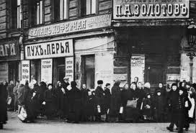

Russo-Japanese War (1905)

Russia was supposed to be great power and wanted to control Korea. The Japanese beat the Russians badly in a series of navel battles.

Because of Social Darwinist ideas and Russia’s size, the Tsar was humiliated.

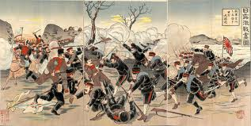

Bloody Sunday (1905)

A crowd of 200,000 workers and their families marched to the Tsar’s Winter Palace in St. Petersburg.

They wanted to present the Tsar with a petition for better working and living conditions.

The protesters stood peacefully in front of the place, singing “God Save the Tsar” and holding religious icons, waiting for the Tsar to come out.

Cossacks and police opened fire on the peaceful protestors, killing hundreds.

