Capitalism and Communism

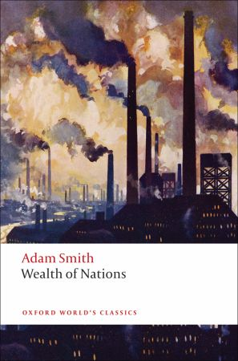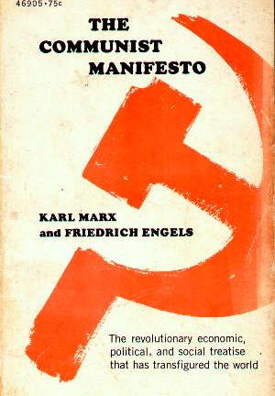

Pace High School | Global History | Tenth Grade | Ms. Collins | November 2014

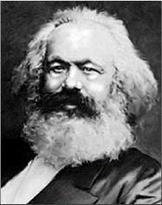 Karl Marx (1818-1883)
Born into a wealthy family in Prussia, Marx went on to study at both the University of Bonn and the University of Berlin. He married a member of the Prussian aristocracy, Jenny von Westphalen. At university, he was interested in Friedrich Hegel’s idea of dialectical materialism, that two social classes are fighting and that is what creates history. He became a journalist in Cologne, Paris, and Brussels and wrote for radical newspapers. He was exiled to London, where he and his family lived in poverty. His and Hegel’s ideas were heavily influenced by what they saw during the British industrial revolution. He and Hegel worked together to formulate the ideals that became Marxism or communism. He published the Communist Manifesto in 1848.

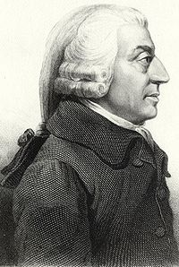 Adam Smith (1723 – 1790)
Born the son of a lawyer in Scotland, Smith went on to study at Oxford University. Working as a tutor, he was able to travel Europe and meet other philosophers of the Enlightenment. Smith spent most of his life as professor. He was dismayed by the absolute monarchies in France, most notably Louis XIV. Trade and banking were starting to become important in the economy and Smith wrote his ideas of how an economy ought to be run in Wealth of Nations, published in 1776.

Adam Smith and Capitalism

Excerpted from The Wealth of Nations (1776) by Adam Smith

“Consumption is the sole end and purpose of all production; and the interest of the producer ought to be attended to, only so far as it may be necessary for promoting that of the consumer.

“It is not from the benevolence of the butcher, the brewer, or the baker that we expect our dinner, but from their regard to their own interest.”

“The propensity to truck, barter and exchange one thing for another is common to all men, and to be found in no other race of animals.”
“Kings and government ministers are themselves always, and without any exception, the greatest spendthrifts [money-wasters] in the society.”

A quick summary

Because all human beings act in their own rational self-interest, according to Smith, people will make and sell what others want to buy. People do things because it serves them, not out of a sense of natural goodness or altruism.

According to his ideas of division of labor, they will find jobs that they can perform to the best of their abilities and be paid according to how society values their labor. Countries, like people, should do what they are best at—a concept known as comparative advantage. Sunny France should produce wine, while chilly Scotland makes wool.

Many people and their businesses will contribute to the economy and find the best ways to do so. By businesses failing or succeeding, people can figure out what prices to set for goods and services. Prices are based on how much people want the good or service (demand) and how much of it exists (supply). Supply and demand’s regulating of goods, services, prices, wages, and employment is characterized by Smith as the “invisible hand” of the market

People and countries should be able to trade with each other, with as little interaction with the government as possible. Smith was against tariffs and heavy or imprecise taxes, like the ones he saw under Louis XIV to pay for France’s wars. Smith believed that government interference could either harm the economy (like Louis XIV) or just be taking profits and productivity it had no role in creating. Government leaving the free market to regulate itself is known as laissez-faire.

QUESTIONS

- Why do people make things and work for a living, according to Smith?

- What will people do, with no direction from a higher authority, like the government?

- What should the role of the government be in the economy? Why?

- What two forces determine what goods and services are made?

- What determines what job you have or how much you earn in wages?

- What is the invisible hand?

Karl Marx and Communism
Excerpted from The Communist Manifesto (1848) by Karl Marx

Class struggle

The history of all hitherto existing society is the history of class struggles.

Freeman and slave, patrician and plebeian, lord and serf, in a word, oppressor and oppressed, stood in constant opposition to one another, fighting. The result is either a revolutionary reconstitution [dramatic change] of society at large, or in the common ruin of the contending classes [when they destroy each other].

Society as a whole is more and more splitting up into two great hostile camps, into two great classes directly facing each other — Bourgeoisie [wealthy middle class] and Proletariat [working class].

Life under communism

In place of the old bourgeois society, with its classes and class antagonisms [conflicts], we shall have an association, in which the free development of each [person] is the condition for the free development of all.

[changes to be made:]

- Abolition of private property
- A heavy progressive or graduated income tax. [This tax is when the rich pay a greater percentage of their income than the poor. So a millionaire would pay 40% of her/his income and a factory worker would pay 10% of her/his income]
- Abolition of all rights of inheritance.
- Nationalization of banking in the hands of the state, by means of a national bank with State capital and an exclusive monopoly.
- Nationalization of the means of communication and transport in the hands of the State.
- Extension of factories and instruments of production owned by the State
- Equal liability of all to work. [everyone would have a job of some kind]
- Establishment of industrial armies, especially for agriculture. [farmers would work together on a big, collective farm]
- Combination of agriculture with manufacturing industries; gradual abolition of all the distinction between town and country by a more equable distribution of the populace over the country. [people be assigned jobs as farmers or factory workers]
- Free education for all children in public schools.

Revolution!

The Communists disdain [refuse] to conceal their views and aims. They openly declare that their ends can be attained only by the forcible overthrow of all existing social conditions, [a revolution]. Let the ruling classes tremble at a Communistic revolution. The proletarians have nothing to lose but their chains. They have a world to win.
Vocabulary:
proletariat
bourgeoisie
dialectical materialism
collective farm
revolution
private property
nationalization
means of production

Workers of the world! Unite!

QUESTIONS

- According to Marx, what is all history?

- What types of groups have been fighting? What will be the result of the fighting?

- What are the two groups that are fighting in 1848, when Marx publishes The Communist Manifesto?

- Please explicate, write in your own words, all the ten changes Marx outlines for a Communist society.

- How will communists achieve these colossal changes?

