Quiz date: Friday, February 13, 2015

Review sheet for Quiz on the First World War
and the Russian Revolution

SHORT ANSWER

- What are the four parts of Global History Regents exam?
- What can you NOT write about in the essays on the Global History Regents exam?
- When was the First World War? What years?
- Please draw a t-chart with the two sides of the First World War.
- What does MAIN stand for, as a pneumonic for the causes of the First World War?
- When was the Russian Revolution?
- Who invented communism? In what book?
- What form of government controlled Russia before 1917 and who was its leader?
- Who was Vladimir Lenin?
- Of what communist group was Lenin the head?
- What was Lenin’s slogan?
- Who is Vladimir Putin? How long has he been in power, roughly?
- Why does Putin make the international community nervous?
- Describe Russia’s geography.
- After 1917, Russia is known by what name?
- What are three causes of the Russian Revolution?
- What are two similarities between the Russian and the French Revolutions?
- Name three communist countries past or present.
- Name five capitalist countries.

MULTIPLE CHOICE

1. The immediate cause of World War I was the
- assassination of Archduke Ferdinand
- Japanese alliance with Germany
- treaty agreement at Versailles
- German invasion of Poland

2. Which event is considered the immediate cause of World War I?
- signing of the Treaty of Versailles
- invasion of Poland by Germany
- assassination of Archduke Francis Ferdinand
- use of unrestricted submarine warfare by Germany

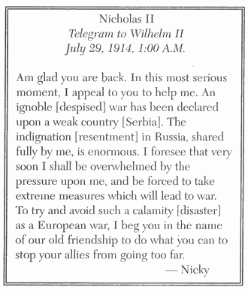
3. Which war is most closely associated with the telegram Nicholas II sent to Wilhelm II?
  - the Franco-Prussian War
  - the Russo-Japanese War
  - World War I
  - World War II

4. Which conclusion is best supported by this telegram?
  - Russia started to mobilize for war against Serbia.
  - Nicholas II condemned the efforts of Wilhelm II.
  - Russia supported the use of extreme measures.
  - Nicholas II hoped diplomacy would prevent war.

5. Which region was described as “the powder keg of Europe” prior to World War I?
- Iberian Peninsula
- British Isles
- Balkan Peninsula
- Scandinavia

"Bombardment, barrage, curtain-fire, mines, gas, tanks, machine-guns, hand-grenades — words, words, but they hold the horror of the world.”
— Erich Maria Remarque, All Quiet on the Western Front
6. This quotation best describes the effects of the
  - technological developments used during World War I
  - formation of alliances in World War II
  - tension between the superpowers during the Cold War
  - protests against reforms during the Indian independence movement

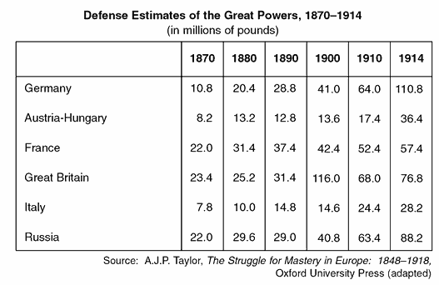

7. Which statement is best supported by the data contained in the table?
  - Austria-Hungary could not afford a large military expenditure in 1880.
  - France spent the greatest amount of money on defense in 1900.
  - Germany rapidly increased its military spending after 1890.
  - Great Britain attempted to prepare for a long ground war.

8. Disintegration of the Austro-Hungarian Empire, creation of new nation-states in central Europe, and Germany’s loss of colonies were all consequences of
- the Napoleonic Wars
- the Franco-Prussian War
- World War I
- The Russian Revolution

9. One reason the League of Nations failed as a world organization was that it
- supported the rise of fascist states
- lacked a military force to settle conflicts
- dealt with conflict by establishing naval blockades
- encouraged the annexation of territory by force

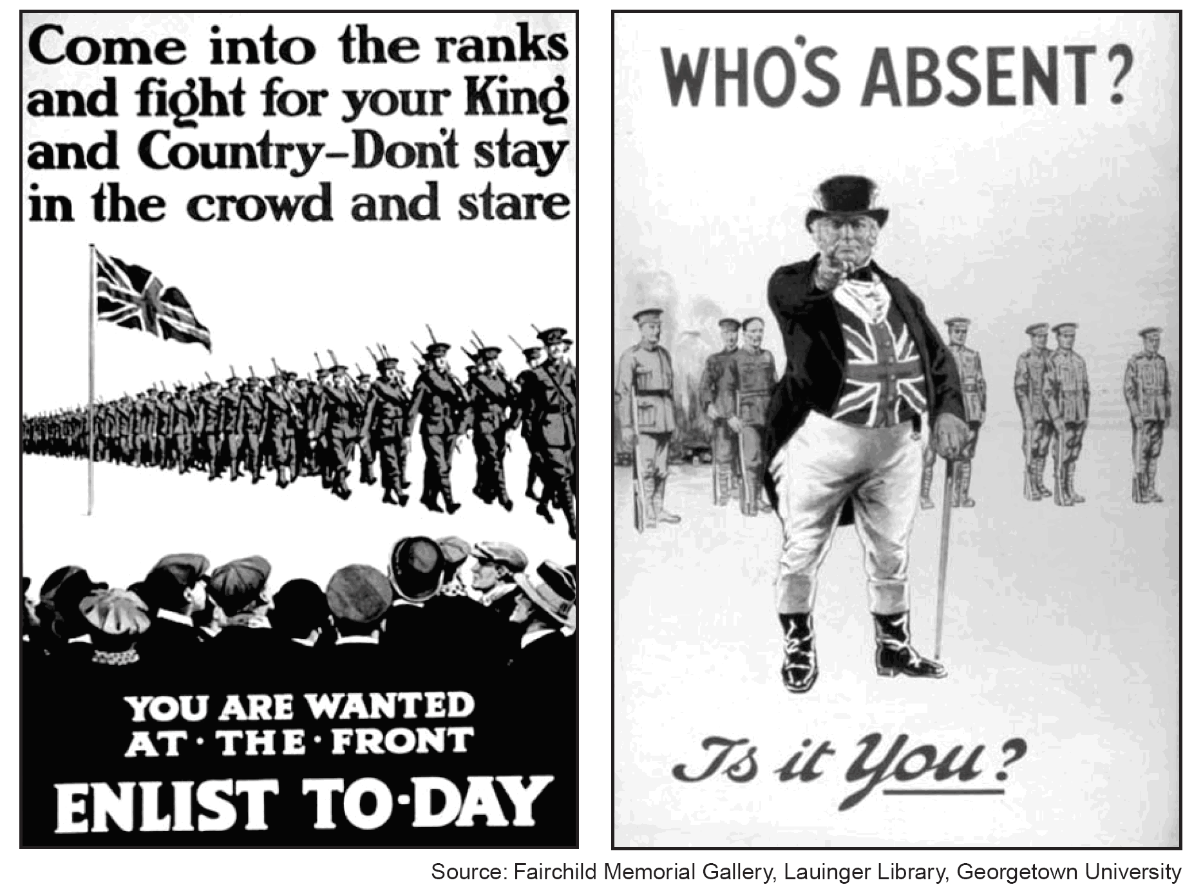
10. Which concept is represented in these World War I recruiting posters?
- justice
- diversity
- nationalism
- humanism

Observation of a Soldier in World War I
Private Archie Surfleet, February 8th, 1918 – We have been in camp near the wood at Écurie for some days now and a more miserable existence it would be hard to imagine. There is nothing but unrest and uncertainty and everyone here is absolutely fed up to the teeth.
- Malcolm Brown, Tommy Goes to War
11. Which hypothesis can best be supported by this passage?
- Allied forces were on the verge of winning the war.
- Technology had created a military stalemate.
- Revolution in Russia hastened the end of the war.
- Conditions contributed to low troop morale

12. One way in which the Council of Trent (1545-1563) and the Versailles Conference (1918-1919) are similar is that they both attempted to
- restore stability after a period of conflict or disorder
- address economic concerns by lowering tariffs
- defend human rights by establishing written codes of law
- encourage cultural development through the creation of universities

13. What was a direct result of World War I?
- Nicholas II was named czar of Russia.
- Germany lost its colonies in Africa and Asia.
- Archduke Franz Ferdinand was assassinated by a terrorist.
- The Ottoman Empire expanded.

14. The success of the women’s suffrage movement in 20th-century Europe resulted in part from women
- holding high political offices
- working in factories during World War I
- being encouraged to have large families
- serving in combat positions during World War I

15. One action that many governments took during World War I was to
- encourage political dissent and freedom of the press
- regulate their economic systems to increase production
- prevent women from seeking employment in factories
- raise tariffs to encourage trade

"If I should die, think only this of me:
That there's some corner of a foreign field.
That is for ever England.
There shall be In that rich earth a richer dust concealed;
A dust whom England bore, shaped, made aware,
Gave, once, her flowers to love, her ways to roam,
A body of England's,
breathing English air,
Washed by the rivers,
blest by suns of home. . . ."
— Rupert Brooke, "The Soldier"

16. Which idea is expressed in this excerpt from Brooke's poem?
  - pacifism
  - neutrality
  - nationalism
  - anarchy

17. Which event occurred first and led to the other three?
  - rise of fascism in Europe
  - Bolshevik Revolution
  - World War I
  - signing of the Treaty of Versailles

18. An incompetent government, massacres on Bloody Sunday, and the high costs of World War I were causes of the
- Mexican Revolution
- Boxer Rebellion
- The French Revolution
- Russian Revolution

19. The Bolshevik Revolution of 1917 in Russia was caused in part by
  - a forced famine in Ukraine
  - the failure of Czar Nicholas II to come to Serbia's aid
  - a shortage of military supplies and food during World War I
  - the establishment of Lenin's New Economic Policy (NEP)

20. What is a major belief associated with Marxism?
  - The proletariat would rise up and overthrow the bourgeoisie.
  - Religion should be more important than political forces.
  - Private ownership of property should be expanded.
  - Peasants would gain control of overseas markets.

21. Which factor led to the rise of communist revolutions in Russia and in China?
  - increase in agricultural production around the world
  - onset of the global depression that restricted trade
  - scarcity of workers for available jobs
  - unequal distribution of wealth between social classes

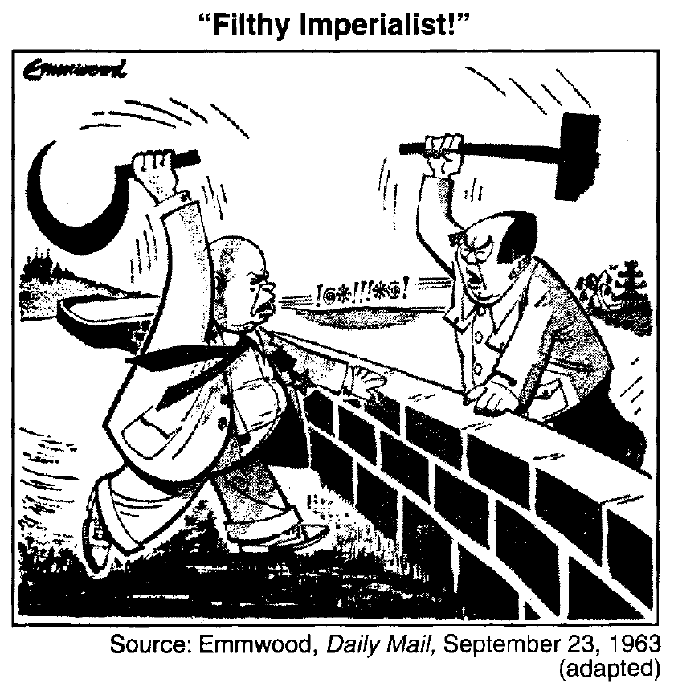
22. The tools shown in this cartoon represent traditional symbols of
- manorialism
- communism
- western capitalism
- national socialism

23. Which two countries are represented by the characters arguing over the border?
- the Soviet Union and China
- North Korea and Great Britain
- China and Great Britain
- the Soviet Union and North Korea

Speaker A: If the rate of population growth continues to exceed the growth in the food supply, there will not be enough food for all of the people.
Speaker B: There are people who are wealthy and people who are poor. This is just how things are.
Speaker C: History is the story of class struggle. Eventually, the working class will rise up and revolt against the wealthy.
Speaker D: The government should do what is best for most of its people.
24. Which speaker best represents the views of Karl Marx?
a. A
b. B
c. C
d. D

25. Which of these groups were the major supporters of 20th-century communist revolutions?
- priests and artisans
- bourgeoisie and nobility
- entrepreneurs and capitalists
- workers and peasants

26. The reason the Bolsheviks gained peasant support during the Russian Revolution was because the Bolsheviks promised to
  - redistribute land
  - abolish communes
  - bring modern technology to Russian farms
  - maintain an agricultural price-support program

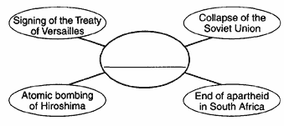

27. Which title best completes this graphic organizer?
- Violations of the Universal Declaration of Human Rights
- Turning Points of the 20th Century
- Reasons for Nonalignment
- Results of the Industrial Revolution

"Czar Abdicates! Provisional Government Formed"
"Peasants Promised Peace, Land, and Bread'"
"Reds and Whites Fight Bloody Civil War"
28. Which revolution is the focus of these headlines?
- Mexican
- Russian
- French
- Cuban

29. Which two major ideas are contained in the writings of Karl Marx?
- survival of the fittest and natural selection
- class struggle and revolutionary change
- separation of powers and checks and balances
- monotheism and religious tolerance

30. The Bolshevik Party in 1917 gained the support of the peasant class because they promised them
- "Peace, Land, and Bread"
- "Liberty, Equality, Fraternity"
- abolition of the secret police
- democratic reforms in all levels of government

31. Heavy military losses in World War I, food and fuel shortages, and opposition to the czar led to the
- French Revolution
- Russian Revolution
- Chinese Revolution
- Cuban Revolution

32. The political reorganization of Russia after the Communist Revolution of 1917 resulted in
- the establishment of a two-party political system
- a limited monarchy with the Czar as a figurehead
- a federation of socialist republics
- increased political power for ethnic minorities

33. Which action was taken by the Bolsheviks under the leadership of Vladimir Lenin?
  - supporting a traditional economy
  - eliminating political opposition
  - surrendering to the Provisional Government
  - extending the war against Austria-Hungary

34. Which action contributed to the success of Lenin's communist revolution in Russia?
- Peasants were promised land reform.
- Businessmen were encouraged to form monopolies.
- Landowners were offered tax relief.
- Factory workers were required to start small businesses.

- Led the Russians in a second revolution (1917)
- Promised "Peace, Land, and Bread"
- Established the New Economic Policy (NEP)
35. Which leader is being described by these statements?
- Czar Nicholas II
- Nikita Khrushchev
- Vladimir I. Lenin
- Mikhail Gorbachev

36. Which leader based his rule on the ideas of Karl Marx and Friedrich Engels?
- Neville Chamberlain
- Vladimir Lenin
- Adolf Hitler
- Jiang Jieshi (Chiang Kai-shek)
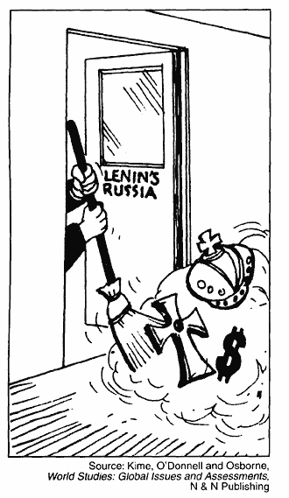
37. In the view of this cartoonist, Russia under Lenin's rule was characterized by
- a continuation of traditional life
- the introduction of capitalism
- support for a constitutional monarchy
- rejection of the czarist system

