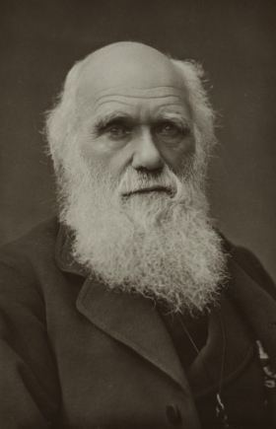
Origins of Social Darwinism
In 1859, Charles Darwin published On the Origin of Species. In this groundbreaking book on his theory of evolution, Darwin wrote that all living things struggle to obtain food, water, and a safe habitat. An organism that is well suited to its environment has the best chance of living long enough to mate and produce offspring. Gradually, as some organisms survive and others die out, new traits, species, and forms of life develop or evolve. Darwin called this process "natural selection."
Many readers at the time immediately saw connections between Darwin’s theory of evolution and their own society. A number of them were influenced by the writings of Herbert Spencer, a British thinker. Referring to Darwin’s work but using his own phrases such as "the struggle for existence" and "the survival of the fittest," Spencer helped popularize a doctrine known as "social Darwinism."
In every country, people interpreted social Darwinism a little differently. In Germany, biologist Ernst Haeckel combined the doctrine with romantic ideas about the German people. In a book called The Riddle of the Universe, he divided humankind into races and ranked each. "Aryans" were at the top and Jews and Africans at the bottom. In the United States and England, social Darwinists stressed the idea that competition rewards "the strong." As a result, many of them opposed aid to the poor, laws that would limit cut-throat competition, and efforts to regulate working conditions. They wanted government to let nature take its course.

Effects of Social Darwinism:

Supporting Imperialism and Empire:

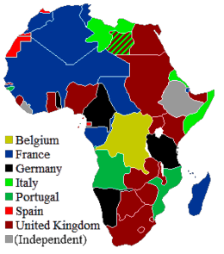
Imperialism is the domination of one country or region by another. The “Age of Imperialism” started in the late 1800s and refers to the efforts of the United Kingdom, France, Germany, Italy, Japan and the United States to control large parts of the rest of the world. Imperialist countries exploited the countries they dominated for resources and organized the foreign governments to suit their control. At the height of Imperialism, most of Africa, the Middle East and China was controlled by European nations. Britain alone controlled almost ¼ of the worlds land at the peak of its empire. Although many of those countries have since gained independence, many of their current problems such as inequality, racial violence and religious struggle were caused by the practices of imperialism.

Social Darwinism has often been linked to imperialism. During the age of New Imperialism, the concepts of evolution was used to justify the exploitation of "lesser breeds without the law" by "superior races." To elitists, strong nations were composed of white people who were successful at expanding their empires, and as such, these strong nations would survive in the struggle for dominance.

The lines of this poem by Rudyard Kipling address this point when he says that it is the “White Man’s burden” to go out and civilize the rest of the world:

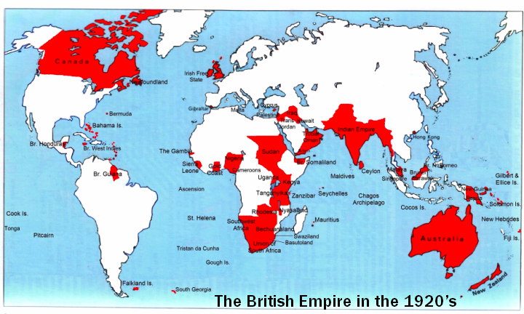
Take up the White Man’s burden—
Send forth the best ye breed—
Go bind your sons to exile
To serve your captives’ need;
To wait in heavy harness,
On fluttered folk and wild—
Your new-caught, sullen peoples,
Half-devil and half-child.

Starting the Field of Eugenics

The word eugenics derives from the Greek word eu (good or well) and genēs (born), and was coined by Sir Francis Galton in 1883. Galton defined eugenics as "the study of all agencies under human control which can improve or impair the racial quality of future generations."

Early eugenicists were mostly concerned with perceived intelligence factors that often related strongly with social class. Many eugenicists took inspiration from the selective breeding of animals (where purebreds are often strived for) as their analogy for improving human society. The mixing of races (or miscegenation) was usually considered as something to be avoided in the name of racial purity. At the time this concept appeared to have some scientific support, and it remained a contentious issue until the advanced development of genetics led to a scientific consensus that the division of the human species into unequal races is unjustifiable.

By 1928, eugenics was part of the curriculum in most high schools as well as in 376 institutions of higher learning—including Harvard, Columbia and Northwestern. According to one survey of 41 textbooks, nearly 90 percent of all high school biology textbooks published between 1914 and 1948 endorsed the movement.

Influenced Nazi Beliefs of Racial Superiority

Nazi Germany under Adolf Hitler was well known for eugenics programs which attempted to maintain a "pure" German race through a series of programs that ran under the banner of racial hygiene. During the 1930s and 1940s, the Nazi regime forcibly sterilized (made it so they cannot reproduce) hundreds of thousands of people whom they viewed as mentally and physically unfit, an estimated 400,000 between 1934 and 1937. Many of the Nazi concerns for eugenics and racial hygiene were also clearly present in their systematic killing of millions of "undesirable" people, especially Jews who were singled out for the Final Solution, this policy led to the horrors seen in the Holocaust.
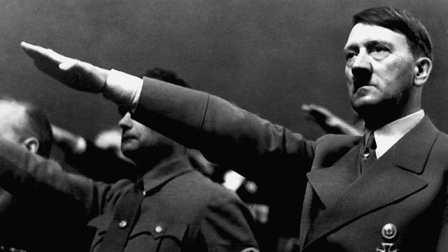
Main Supporters of Social Darwinism:
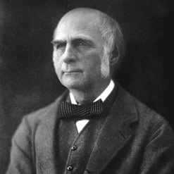
Francis Galton (1822-1911) is considered the founder of the eugenics movement. Galton came from a prominent English family and studied medicine at Cambridge University. He gave up medicine but remained intensely interested in the nature of human differences. He was inspired by the work of his famous cousin, Charles Darwin, to begin his own investigations into the role heredity played in intelligence, poverty, and criminality. In his first book on the topic, Hereditary Genius (1869), he claimed that notable figures in English and European history owed their accomplishments to their superior racial stock.
Galton had been attracted to the ideology of Social Darwinism, which justified social inequalities as a natural result of the “survival of the fittest “ between superior and inferior members of humanity. By the 1880s Galton claimed this theory was not working because too many of the inferior classes and races were kept alive through “false philanthropy.” In 1883 he invented the term eugenics to restore what he saw as nature’s proper course. Galton promoted eugenics as a modern science with a civic purpose where the most fit should have more children and the less fit should be discouraged from reproducing. While his ideas never attracted a wide audience in England, his ideas generated great interest and influenced public policies in the United States and later on in Nazi Germany.

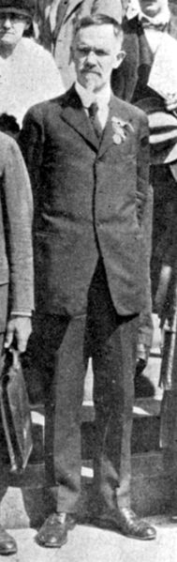
Charles Davenport (1866-1944) is considered the founder of the American eugenics movement and was one of the most influential figures both nationally and internationally in the history of eugenics. Davenport was a professor in zoology at the University of Chicago before he was appointed as the director of the Eugenics Record Office (ERO) in Cold Spring Harbor in 1910.
Davenport saw himself as a progressive reformer, believing the "science of eugenics" could cure society of such ills as poverty, crime, and feeblemindedness. Through his writings, ERO publications, and the lobbying efforts of the center, Davenport made eugenics a major force in shaping public policies. Davenport and the ERO played a major role in advocating for immigration restriction based on racial quotas, stricter enforcement of anti-miscegenation laws in American states, and state sterilization statutes against those deemed "eugenically unfit."

Eugenics is the science of the improvement of the human race by better breeding or, as Galton expressed it:

”The science which deals with all influences that improve the inborn qualities of a race.” The eugenical standpoint is that of the agriculturalist who, while recognizing the value of culture [environment], believes that permanent advance is to be made only by securing the best “blood.” Man is an organism—an animal; and the laws of improvement of corn and race horses hold true for him also. Unless people accept this simple truth and let it influence marriage selection, human progress will cease. . . .

Opposition to Social Darwinism

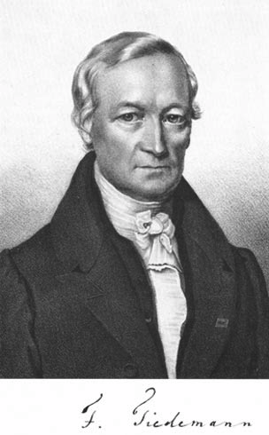
Friedrich Tiedemann (1781-1891) was a German physiologist who believed that there were no fundamental differences in intellectual or moral worth between “races” and the sexes. Tiedemann’s ground-breaking work, “On the Brain of the Negro, compared with European and the Orang-Outang (1836),” disproved popular notions about African intellectual inferiority.
Tiedemann compared Europeans, orangutans, and Africans and found no difference between African and European brain or nerve structures. After adjusting for body differences, Tiedemann found that African and European brains weren’t different at all. Based on the idea that intelligence was directly related to brain size, Tiedemann concluded that African intelligence was equal to that of Europeans. He even took his conclusion a step further to state that women’s brains, when adjusted for women’s smaller stature, might be larger than men’s brains.
Tiedemann’s research and conclusions set him apart from almost all other European and North American scientists studying human differences. His work stood in stark contrast to the more well known studies by the American anthropologist, Samuel Morton. Morton argued that skull sizes from the different races proved the intellectual superiority of white European and Americans over darker skinned peoples. Tiedemann’s work had more scientific merit, and his ideas laid the groundwork for researchers in the 20th century who further undermined the foundations for scientific racism.

Science and Race Today

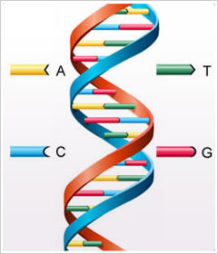
Eugenicists divided the world into “races” and insisted that some “races” (their own in particular) were superior to others. In the early 1900s, the American Museum of Natural History in New York City organized its exhibitions around eugenic principles. In 2001, the museum opened a new exhibit entitled “The Genomic Revolution.” In a prominent place, the organizers featured the following statement:

The Only Race Is Human Race

No Biological Basis for Race

New data from the mapping of the human genome reveal that all humans are incredibly similar—in fact, we are 99.9% genetically identical. We are all members of one species, Homo sapiens. Scientists have confirmed, as they long suspected, that there is no genetic or biological basis for race.
Genetic variation between people within the same “racial” group can be greater than the variation between people of two different groups. Many people of African descent are no more similar to other Africans than they are to people of European descent. Genetic distinctions between Asians and Europeans are less pronounced than those between groups from, for example, parts of East and West Africa.
No matter how scientists today scrutinize a person’s genes, they can’t determine with certainty whether an individual is from one “racial” group or another. Differences of culture and society distinguish one group from another, but these distinctions are not rooted in biology.

