War Debts  France has been fighting various wars for nearly 100 years. As a result of these wars they fall These debts lead to an increase in taxation | King’s Absolute Power  Louis XVI’s power was absolute. He did not listen to others’ advice. The Estates-General had not been called since 1614. Even if it was called, the Estates-General voted by Estate, not by person. Effectively, French people cannot vote.
The King/Queen’s Public Image  Louis XVI hated appearing in public. Marie Antoinette was vilified in the press for her [alleged] affairs and for her love of expensive clothing, lavish parties, and high-stakes gambling. | Terrible & Corrupt Bureaucracy  Offices were bought and paid for, including courts.

Starving Peasants  The harvest and the winter of 1788 and 1789 were one of the worst on record. Peasants were starving to death. | Literacy Rates Increase  Literacy increases from 1/5 to 1/3. Paris had a daily newspaper and smaller towns had weeklies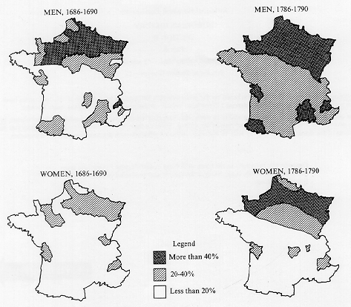
Tax system  The First Estate, the Clergy, pays 0% in taxes. They own 10% of the land. They are 0.5% of the population.  The Second Estate, the Nobility, pays 0% in taxes. They own 25% of the land. They are 1.5% of the population.  The Third Estate, everyone else, pays 50% in taxes. They own 65% of the land. They are 98% of the population. | Interest in the British system and Enlightenment ideas  Upper Bourgeoisie and the lower nobility admired the British system, with its Bill of Rights and the Magna Carta. Also some admired the American Revolution. Furthermore, the ideas of the Enlightenment had captured people’s imaginations.

