Name _________________________________ Date _________________ Period ____________
Worksheet on Feminism
Women and the Home
Historically:

Currently:

Statistic:

Women and Work
Historically:

Currently:

Statistic:

Women and Education
Historically:

Currently:

Statistic:

Women and Politics
Historically:

Currently:

Statistic:
Women’s Equality – In the Home
In many prehistoric cultures, women assumed a particular cultural role. In hunter-gatherer societies, women were generally the gatherers of plant foods, small animal foods, fish, and learned to use dairy products, while men hunted meat from large animals.
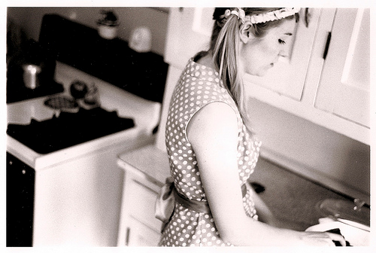
In more recent history, the gender roles of women have changed greatly. Traditionally, middle-class women were typically involved in domestic tasks emphasizing childcare. For poorer women, especially working class women, although staying at home often remained an ideal, economic necessity compelled them to seek employment outside the home. The occupations that were available to them were, however, lower in pay than those available to men.
The division of labor within households was affected by the increased entry of women into workplaces in the 20th century. However, Sociologist Arlie Russell Hochschild found that, in two-career couples, men and women, on average, spend about equal amounts of time working, but women still spend more time on housework.
Like their adult counterparts, girls are more likely than boys to perform unpaid work within their own household. In the less developed regions, many young girls aged 5-14 take on a large amount of household chores, including care-giving, cooking and cleaning, and older girls do so to an even greater extent. While boys also do household chores, their participation rate is not as high as that of girls.
Women’s Equality – In Politics
Historically, women have rarely held positions of power in politics with a few exceptions such as Queen Elizabeth I and Catherine the Great. When countries in Europe started to become democracies, only men, and often only white men with property were allowed to vote.
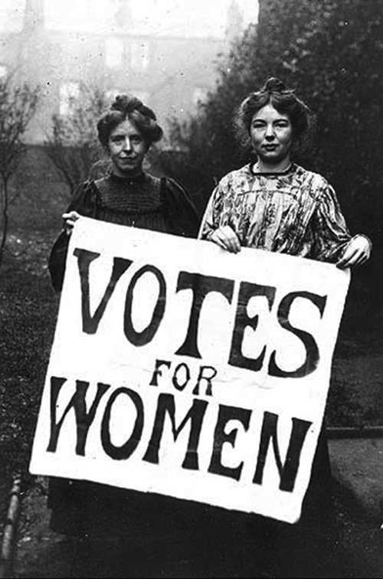
Women first fought for the right to vote in a movement called Women’s suffrage which started in France in the late 1800s. After much effort and struggle on behalf of many dedicated men and women, women stated to receive the right to vote in many countries in the early 1900s, but it took many countries much longer. This is especially true in the Middle East where many women have only gained the right to vote in the last 20 or 30 years and Women in Saudi Arabia will vote for the first time in 2015.
Today, although most women are given the right to vote, women continue to hold few of the positions of power. Women continue to be underrepresented in national parliaments, where on average only 17 per cent of seats are occupied by women. The share of women among ministers also averages 17 per cent. The highest positions are even more elusive: only 7 of 150 elected Heads of State​ in the world are women, and only 11 of 192 Heads of Government. The situation is similar at the level of local government: female elected councilors are underrepresented in all regions of the world and female mayors even more so.
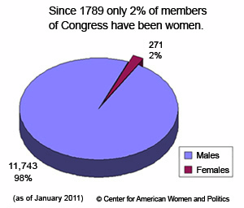
In the United States, men make up 83% of Congress, a situation which has been largely unchanged for the last 30 years. One explanation for this is that incumbents win more than 90% of the time and most incumbents are currently men. So despite the fact that women are just as likely to win open seats as men and just as likely to be able to draw the financial means, they remain at a structural disadvantage from which they are unlikely to achieve equality within our lifetimes.
Indeed, the evolution of equality is rarely organic. Of the 25 nations that have realized a greater than 30% female participation in their governments, 90% required some form of temporary jump-start to secure permanent gains.
Women’s Equality – At Work
Historically there has been a gap between upper or middle class women who largely stayed at home and poorer women who needed to work to support their families. In agricultural societies, women were often the primary laborers in the field and in many countries still play that role.
Feminist Movements advocate equality of opportunity for both sexes and equal rights irrespective of gender. Through a combination of economic changes and the efforts of the feminist movement, in recent decades women in most societies now have access to careers beyond the traditional homemaker.
As changes in the labor market for women came about, availability of employment changed from only "dirty", long houred factory jobs to "cleaner", more respectable office jobs where more education was demanded, women's participation in the labor force rose. These shifts in the labor force led to changes in the attitudes of women at work, allowing for the revolution that resulted in women becoming career and education oriented.
Globally, women’s participation in the labor market remained steady in the two decades from 1990 to 2010, hovering around 52 per cent. In contrast, global labor force participation rates for men declined steadily over the same period, from 81 to 77 per cent. In 2010, women’s labor force participation rates remain below 30 per cent in Northern Africa and Western Asia; below 40 per cent in Southern Asia; and below 50 per cent in the Caribbean and Central America. The gap between participation rates of women and men has narrowed slightly in the last 20 years but remains considerable. The smallest gender gaps are in the early adult years and the widest in the prime working ages.
However, despite women increasingly entering the workforce, there is still inequality in payment and participation in top jobs. In the U.S., for example, there is a 23% earnings gap between men and women. In the United Kingdom, women earn 23% less than men. While more women today are entering business school, they graduate into a corporate environment fraught with inequity. Female MBA grads worldwide start at lower positions than equally qualified men, are paid less and get fewer promotions. Of the Fortune 1000 companies in the U.S. 16 have female CEOs.
Women’s Equality – In Education
Historically, because men held most of the positions of power and importance, education was mainly only available to males with money or influence. Actual progress in institutional terms, for secular education of women, began in the West in the nineteenth century, with the founding of colleges offering single-sex education to young women. This movement slowly expanded until universal public education for both boys and girls has become the standard in most countries.
There is still much room for improvement however. Today, in the poorest countries of the world, 50% of girls do not attend secondary school. Yet, research shows that every extra year of school for girls increases their lifetime income by 15%. Improving female education, and thus women's earning potential, improves the standard of living for their own children, as women invest more of their income in their families than men do. Yet, many barriers to education for girls remain. In some African countries, such as Burkina Faso, girls are unlikely to attend school for such basic reasons as a lack of private latrine facilities for girls.
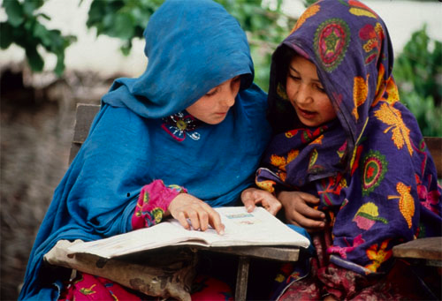
However, reflecting the persistent disadvantages they face, women account for two thirds of the world’s 774 million adult illiterates – a proportion that is unchanged over the past two decades. While the overall progress in primary education in the past decade is encouraging, major barriers stand in the way of progress: 72 million children – 54 per cent of them girls – are out of school.
In the richer countries, the situation is much different. Younger women today are far more likely to have completed high school: in 19 of the 30 members of the developed countries, more than twice as many women aged 25 to 34 have completed high school than have women aged 55 to 64. In 21 of 27 of these countries with comparable data, the number of women graduating from university-level programs is equal to or exceeds that of men. 15-year-old girls tend to show much higher expectations for their careers than boys of the same age.
In the developed world, women have surpassed men at many levels of education. For example, in the United States in 2005/2006, women earned 62% of Associate's degrees, 58% of Bachelor's degrees, 60% of Master's degrees, and 50% of Doctorates.

