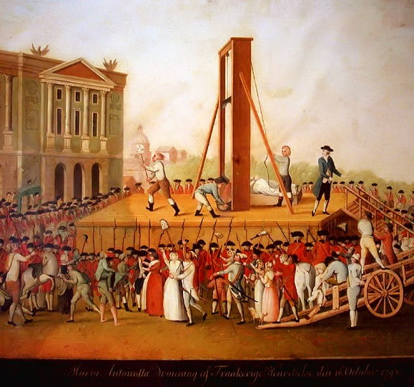

Reign of Terror
during the French Revolution

Collins | Global History III | October 2011

Speech to the National Convention on February 5, 1794
Republic of Virtue by Maximilien Robespierre

Between 1793 and 1794, France experienced the most radical phase of the Revolution, the Reign of Terror. Maximilien Robespierre (1758 1794) was the leader of the twelveman Committee of Public Safety chosen by the National Convention, and which effectively governed France at the height of the Reign of Terror. In the five months from September, 1793, to February 5, 1794, the revolutionary tribunal in Paris convicted and executed 238 men and 31 women and on February 5 there were 5,434 individuals in the prisons in Paris awaiting trial.

Robespierre was frustrated with the progress of the revolution. After issuing threats to the National Convention, he himself was arrested in July 1794. He tried to shoot himself but missed, and spent his last few hours with his jaw hanging off. He was guillotined, as a victim of the terror, on July 28, 1794.

[A] What is the goal for which we are reaching? The peaceful enjoyment of liberty and equality . . . What kind of government can realize these ideals? A democratic or republican government only.... A democracy is a state where the sovereign people, [are] guided by laws of their own making . . . We wish to substitute in our country ... all the virtues and miracles of the republic for all the vices and absurdities of the monarchy.

[B] But, to found and consolidate democracy, to achieve the peaceable reign of the constitutional laws, we must end the war against tyranny and pass safely across the storms of the revolution: such is the aim of the revolutionary system that you have enacted.

[C] We wish that France . . . may . . . become a model to nations [and] that, by sealing our work with our blood, we may witness at least the dawn of universal happiness-this is our ambition, this is our aim.

[D] It is necessary to annihilate the enemies of the Revolution or perish with them. Now, your first rule of politics should be to lead the people by reason and lead the enemies of the Revolution by terror.

[E] If the basis of government in peacetime is virtue, the basis of government during a revolution is both virtue and terror. Terror without virtue is murderous; virtue without terror is powerless. Terror is nothing other than justice that is swift, severe, and inflexible . . .

Excerpted from http://teachers.sduhsd.k12.ca.us/tpsocialsciences/world_history/dem_ideals/robespierre.htm

Louis Antoine Léon de Saint-Just

Saint-Just was an icy, uncompromising young revolutionary. He waged war on all who opposed the Revolution. He served on the Committee on Public Safety and was a close colleague of Robespierre. He was executed at age twenty-six in 1794.

[A] The vessel of the Revolution can arrive in port only on a sea reddened with torrents of blood . . . A nation regenerates itself only upon heaps of corpses.

[B] [written after the execution of King Louis XVI] Those who make revolutions by halves dig their own graves.

[C] In the circumstances in which the republic finds itself, the constitution cannot be inaugurated; it would destroy itself ... The provisional government of France is revolutionary until there is peace.

[D]You have to punish not only the traitors, but even those who are indifferent; you have to punish whoever is passive in the republic, and who does nothing for it.

Jean-Paul Marat
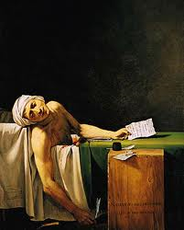
Marat was the publisher of a radical newspaper called “The Friend of the Peuple” (L’Ami du Peuple). From the earliest days of the Revolution, Marat demanded the death by guillotine for all supporters of the King. He encouraged mob violence in the streets of Paris. He and Robespierre instigated the Reign of Terror. He was killed in his bathtub.

“Look around! You’ve been betrayed! You are hungry, while they have bread. Your government, ninnies and cowards, are afraid to set a revolutionary order. They’ve betrayed us to aristocrats, moneylenders, and profiteers . . . We’ll clean ourselves! All parasites to the guillotine! This is the way to save the Revolution!

The guillotine

It was invented by a doctor and member of the National Assembly, Joseph Guillotine. It was the primary killing device used during the French Revolution for executions that uses a large metal blade to cut a person’s head from his or her body.

- The executioner cranked up the blade and let it fall, severing the victim's head from his or her body.
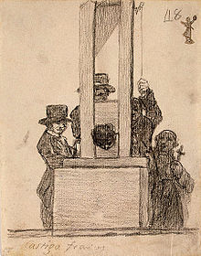

- Before each execution, bound victims traveled from the prison in a 1.5-hour procession through the streets.

- Vendors would sell programs listing the names of those scheduled to die; people would come day after day and vie for the best seats; parents would bring their children.

- Knitting female citizens, called tricoteuses, formed a cadre of hardcore regulars, often getting the crowd excited

The Law of Suspects (1793)

“Suspects shall be locked up…. The proof necessary to convict enemies…can be any kind of evidence….If proof already exists there need be no further witnesses….The penalty for all offences under the law of revolutionary tribunal is death.”

from the Execution Record, 1793.

A woman was charged with the crime of having wept at her husband’s execution…she was condemned to sit for hours under the blade which shed upon her, drop by drop the blood of her dead husband…before she was released by death…

Jean Julien, wagon driver having been sentenced to twelve years hard labor, took it into his head to cry ‘long live the king’, brought back to the Tribunal and condemned to death.

François Bertrand, aged 37, a bar owner, convicted of having provided the defenders of the country with sour wine, condemned and executed the same day.

Henriette Marboeuf, aged 55, convicted of having hoped for the arrival of the Austrians and Prussians and of keeping food for them, condemned to death and executed the same day.

Marie Plaisant, seamstress, convicted of having exclaimed that she was an aristocrat and that she did not care a fig for the nation, condemned to death and executed the same day.

Jean-Baptiste Henry, aged 18, journeyman tailor, convicted of having sawn down a tree of liberty, executed 6th September, 1793.

Times of London (Sept. 10, 1792)

Are these "the Rights of Man"? Is this the LIBERTY of Human Nature?

The streets of Paris, strewed with the carcasses of the mangled victims, are become so familiar to the sight, that they are passed by and trod on without any particular notice.

In the massacre last week, every person who had the appearance of a gentleman, whether stranger or not, was run through the body with a pike. He was of course an aristocrate [nobleman], and that was a sufficient crime. A ring, a watch chain, a handsome pair of buckles, a new coat, or a good pair of boots in a word, everything which marked the appearance of a gentleman, and which the mob fancied, was sure to cost the owner his life.

Who was executed? One of the first to be executed was Marie-Antoinette, the former Queen. It is impossible to estimate how many people met their deaths. More than 12,000 were officially guillotined, but many others were shot, drowned, or put to death some other way.

The Terror was supposed to help the revolution survive, but it was not just the former members of the first and second estates who suffered at its hands. Of the 12,000 or so who were guillotined, 674 were from the clergy, 1,031 were nobles; 2,923 were from the bourgeoisie, and 7,878 were urban workers and peasants.

chart of executions by estate

