10th grade global history
Collins | September 2011
The Enlightenment
Part 1

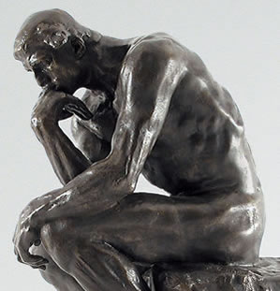
Essential questions:
- What is human nature?
- How should society be governed?
- Can a society ever be perfect? What makes a society function better or worse?

Essential Skills
- Making meaning of the text (main idea, supporting evidence, and narrative)
- Viewing text from multiple-perspectives
- Speaking and listening
- Providing arguments based on reason and evidence

After the Renaissance, Europeans begin to rediscover an interest in the workings of the world around them. During the Scientific Revolution, Copernicus, Galileo, Newton and others changed people’s understanding of the natural world and the universe. Francis Bacon pioneered the scientific method, which allows people to discover and test new ideas with experiments.

Influenced by the scientific methods and thinking, philosophers begin to formulate new ideas of human nature and search for the most scientific way to construct governments and laws. Since Isaac Newton and others were able to understand why how light refracted or gravity functioned, philosophers believed that they could scientifically discover how to make a perfect society. This period in intellectual history, when many French and English philosophers invented new ideas to understand humanity, society, and government, is known as the Enlightenment.

The Enlightenment has a disproportionately large influence on Americans, because America’s founders (Thomas Jefferson, James Madison, and Alexander Hamilton) were profoundly influenced by these writings. Because the United States is the only nation to have a constitution over 200 years old, many of our country’s laws are firmly rooted in these philosophies. We are a nation formed by the philosophies of the Enlightenment.

John Locke (1632-1704)
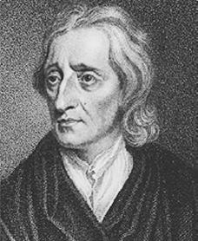

Locke’s father was a lawyer and clerk in Somerset, England. Locke spent his life surrounded by politics, as his father worked for Parliament. Locke attended the Westminster School and Oxford University. Locke earned a degree in medicine and was hired as the personal physician and consultant to the Earl of Shaftsbury, who was the founder of the Whig party and prominent in the Glorious Revolution. Locke had to flee to the Netherlands for writing against King James II. During his exile, in 1690, he wrote his two most famous works: An Essay Concerning Human Understanding and Two Treatises of Civil Government. King James II was overthrown in the Glorious Revolution, and Locke was allowed to return to England as a favorite of the new monarchs, King William and Queen Mary. Locke wrote his greatest works in response to the upheaval of the Glorious Revolution in England, but its influence has extended far beyond that event.

1. According to Locke, in a “state of nature,” with no government, how should people behave? (TWO ideas)

“[man] has not liberty to destroy himself, or so much as any creature in his possession . . . The state of nature has a law of nature to govern it [which is] reason, which teaches all mankind, that being all equal and independent, no one ought to harm another in his life, health, liberty, or possessions..” (Two Treatises of Government, Chapter 2)

In your words:

2. According to Locke, what is equality?

[Equality is ...] "That equal right which every man hath, to his natural freedom, without being subjected to the will or authority of any other man". (Two Treatises of Government, chapter 6).

In your words:

3. According to Locke, are all human beings the same?

“Different degrees of industry were apt to give men possessions in different proportions. And as different degrees of industry were apt to give men possessions in different proportions, so this invention of money gave them the opportunity to continue and enlarge them.”

In your words:

4. According to Locke, why can’t we live in a state of nature?

"He [God] and all the rest of mankind are one community, make up one society distinct from all other creatures. And were it not for the corruption, and viciousness of degenerate men, there would be no need of any other [type of society] (Two Treatises of Government, Chapter 9).

In your words:

6. According to Locke, why should a society have laws? (TWO ideas)

"The end of law is not to abolish or restrain, but to preserve and enlarge freedom . . . And that all men may be restrained from invading others' rights, and from doing hurt to one another, and the law of nature be observed, which willeth the peace and preservation of all mankind (Two Treatises of Government, Chapter 6 and 2).

In your words:

7. According to Locke, what is the purpose of a government? (THREE ideas)

"Government being for the preservation of every man's right and property, by preserving him from the violence or injury of others, is for the good of the governed.”

In your words:

8. According to Locke, what is the mind to begin with? How do we learn things?

Let us then suppose the mind to be, as we say, white paper void of all characters, without any ideas. How comes it to be furnished? Whence comes it by that vast store which the busy and boundless fancy of man has painted on it with an almost endless variety? Whence has it all the materials of reason and knowledge? To this I answer, in one word, from experience. (Essay Concerning Human Understanding)

In your words:

Thomas Hobbes (1588-1679)
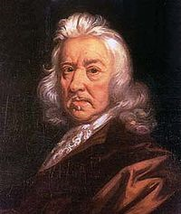
Born in Wiltshire, England, Hobbes was the son of a vicar (church deputy), and was educated at Oxford University. He was hired as the tutor to the children of wealthy members of parliament and princes. His greatest contribution was to political philosophy, but he was also a scientist and mathematician. He fled for France during the English Civil War, when King Charles I was executed. During this time, English society was divided religiously, economically, and by region. He wrote his most famous work, Leviathan, in 1651.

1. According to Hobbes, are all humans the same?

Nature hath made men so equal in the faculties of body and mind as that, though there be found one man sometimes manifestly stronger in body or of quicker mind than another, yet when all is reckoned together the difference between man and man is not so considerable as that one man can thereupon claim to himself any benefit to which another may not pretend as well as he.

In your words:

2. According to Hobbes, does everyone think s/he is the same?

“they will hardly believe there be many so wise as themselves; for they see their own wit at hand, and other men's at a distance.”

In your words:

3. According to Hobbes, how do people behave in a “state of nature”? (THREE ideas)

if any two men desire the same thing, which nevertheless they cannot both enjoy, they become enemies; and in the way to their end . . . endeavor to destroy or subdue one another . . . men have no pleasure (but on the contrary a great deal of grief) in keeping company where there is no power able to overawe them all.

In your words:

4. According to Hobbes, how do people behave without government?

Hereby it is manifest that during the time men live without a common power to keep them all in awe, they are in that condition which is called war; and such a war as is of every man against every man.

In your words:

5. According to Hobbes, what happens in this constant state of war? Make a list.

[In war] there is no place for industry; no culture of the earth; no navigation; no commodious building; no knowledge; no account of time; no arts; no letters; no society; and which is worst of all, continual fear, and danger of violent death;

the life of man [is] solitary, poor, nasty, brutish, and short.

In your words:

6. According to Hobbes, what sort of government is best? (TWO ideas)
The only way to [avoid a constant state of war and have a functional society], is to confer all their power and strength upon one man, I authorize and give up my right of governing myself to this man, . . . This is the [beginning] of that great Leviathan, or rather, to speak more reverently, of that mortal god to which we owe, under the immortal God, our peace and defense. . . . And he that carryeth this [power] is called sovereign, and said to have sovereign power; and every one besides, his subject.

In your words:

7. How does the illustration show Hobbes’ beliefs about government?

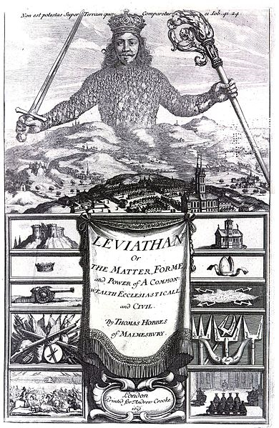

abolish: get rid of
apt: appropriate
authorize: approve
awe: fear and amazement
boundless: unlimited
carryeth: has
commodious: large and spacious
confer: give
considerable: a lot
corruption: dishonesty
culture of the earth: farming
degenerate: evil
endeavor: try
enlarge: make bigger
faculties: abilities
fancy: imaginings
furnished: filled up
governed, the: the citizens]
hath: have
hereby: from now on
industry: motivation and hard work
Leviathan: a sea monster from the Bible
liberty: freedom
manifest: obvious
manifestly: obviously
mortal: will die, not immortal
preservation: protection
proportions: amounts
reason: logical thinking
reckoned: thought of
restrain: hold back
reverently: respectfully
sovereign: having supreme political power
subdue: to conquer or beat
subject: a person ruled by a king or queen
thereupon: based on
to be subjected to: to be under the control of
vast: a lot
viciousness: meanness, nastiness
whence: why?
will: force
willeth: forces
wit: intelligence

 | Locke | Hobbes
What is human nature? What are humans like without the influence of society?
What is society like in a state of nature?

Are all human beings the same?
Why cannot everyone just live in a state of nature?
What is the purpose of government?

What is the best form of government?

