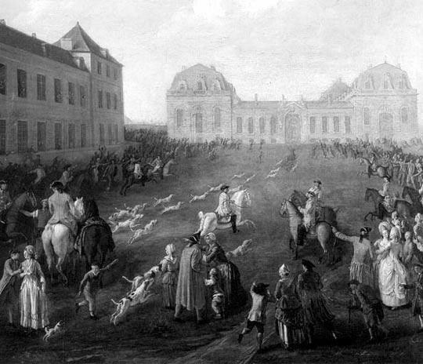

L’Ancien Régime français
the Old Regime in France

Collins | Global History III | October 2016

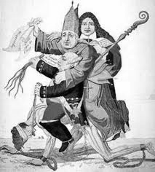

a political cartoon of the Three Estates
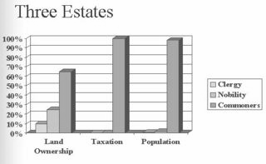

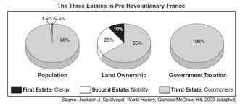
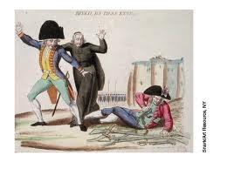
The French Revolution was not one event, but a series of events. The causes of the French Revolution are similarly complicated, so complicated that a debate still rages among historians regarding origins, causes, and results. In general, the real causes of the Revolution must be located in the rigid social structure of French society during the Ancien Régime. As it had been for centuries, French society was divided into three Estates or Orders. The First Estate consisted of the clergy and the Second Estate the nobility. Together, these two Estates accounted for approximately 500,000 individuals. At the bottom of this hierarchy was the vast Third Estate which basically meant everybody else, or about 25 million people. This social structure was based on custom and tradition, but more important, it was also based on inequalities which were sanctioned by the force of law. So, we must look at these three Estates more carefully.
The First Estate
The French Catholic Church maintained a wide scope of powers - it literally constituted a state within a state and it had sustained this position for more than 800 years. The clergy was divided into the lower and upper clergy. Members of the lower clergy were usually humble, poorly-paid and overworked village priests. As a group, they resented the wealth and arrogance of the upper clergy.

The bishops and abbots filled the ranks of the upper clergy, men who regarded their office as a way of securing a larger income and the landed property that went with it. Most of the upper clergy sold their offices to subordinates, kept the revenue, and lived in Paris or at the seat of royal government at Versailles. The clergy’s responsibilities included: the registration of births, marriages and deaths; they collected the tithe (usually 10%); they censored books; served as moral police; operated schools and hospitals; and distributed relief to the poor. They also owned 10-15% of all the land in France. This land, of course, was all held tax-free.
The Second Estate

The nobility held the highest positions in the Church, the army, and the government. As an order, they were virtually exempt from paying tax (la taille) of any kind.

They collected rent from the peasant population who lived on their lands. They also collected an extraordinary amount of customary dues from the peasantry. There were forced to perform labor for the nobles (the corvee). As well as pay dues on salt, cloth, bread, wine and pay for the use of mills, granaries, presses and ovens.

Collectively, the nobility owned about 30% of the land. By the 18th century, they were also becoming involved in banking, finance, shipping, insurance and manufacturing. They were also the leading patrons of the arts. It is interesting that the nobility would offer their homes and their salons to the likes of Voltaire, Gibbon, Diderot and Rousseau. After all, these were the men who would end up criticizing the Second Estate. Of course, it must also be that the philosophes could not have existed without their aristocratic patrons.

There were, like the clergy, two levels of the nobility (c.350, 000 individuals in total). The higher levels of nobles served their King at his court in Versailles. Many higher-level nobles were of ancient lineage - their family history could be traced back hundreds of years.

The Third Estate

This estate ostensibly consisted of everyone who was not a member of either the First or Second Estates. Totaling approximately 25 million people, the Third Estate was composed of the bourgeoisie, city dwellers, and the peasantry.

As a class, the bourgeoisie - merchants, manufacturers, bankers, doctors, lawyers, intellectuals - had wealth. But, wealth in the ancien régime did not mean status or privilege. Wealth was nothing without status. The bourgeoisie were influenced by the nobility and tried to imitate them whenever possible. So, they tried to improve their status by becoming land owners themselves. By 1789, the bourgeoisie controlled 20% of all the land. They were upwardly mobile, but they felt frustrated and blocked by the aristocracy, an aristocracy whose only interest was that everyone maintain their place in society.

By 1789, the bourgeoisie had numerous grievances they wished addressed. They wanted all Church, army and government positions open to men of talent and merit. In the ancien régime, government offices and lower-level noble titles were sold to make more money for the king.

The bourgeoisie sought a parliament or congress that would make all the laws for the nation. They desired a constitution that would limit the king's powers. They also desired fair trials and religious toleration. In French courts, judges earned their jobs by paying for their position and bribes were common. The bourgeoisie admired the limited monarchy of England, where the king shared power with Parliament

The peasantry consisted of at least twenty-one million individuals during the 18th century. The French peasant continued to live in utmost poverty. Collectively, the peasantry owned 30-40% of the available land but mostly in small, semi-feudal plots. Most peasants did not own their land but rented it from those peasants who were wealthier or from the nobility. They tried to supplement their income by hiring themselves out as day laborers, textile workers or manual laborers.

Peasants were victimized by heavy taxation - taxes were necessary to pay for the costs of war, something that had already consumed the French government for an entire century. France had fought (and mostly lost) wars with Great Britain to preserve their territory in the Caribbean and North America. Because they had lost, they had lost profitable sources of revenue from trade in India, China, Canada, and the Caribbean. They had lost the Seven Years War with Prussia (1756-63). France had also helped the Americans win independence from England in the American Revolution. All of these wars resulted in a huge national debt, too many loans from bankers, and not enough tax revenue.

So, the peasants paid taxes to the king (la taille), taxes to the church, taxes and dues to the lord of the manor, as well as numerous indirect taxes on wine, salt, and bread. Furthermore, the peasants also owed their lord a labor obligation (the corvée).

And throughout the 18th century, the price of rent was always increasing, as did the duties levied on goods sold in markets and fairs. By 1789, the plight of the French peasant was obvious. Taxes were increased as was rent. Peasants continued to use antiquated methods of agriculture. The price of bread soared and overall, prices continued to rise at a quicker rate than wages. To make matters worse, there was the poor harvest of 1788-89.

These, then, are the social causes that acted as a breeding ground for the grievances and passions the Revolution would unleash. But there are a few other causes, equally important, that are also worth our attention.

Finances
By 1789, France was bankrupt. The country could no longer pay its debts, debts that were all the result of war. One example says a great deal about this situation. By 1789, France was still paying off debts incurred by the wars of Louis XIV, that is, wars of the late 17th and early 18th century. Furthermore, the clergy and the nobility did not pay taxes of any kind. The king continued to tax the peasants - peasants who, having nothing to contribute were, over the course of the century, forced to contribute even more.

The King and Queen
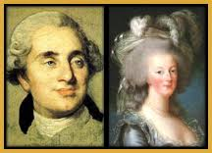
Eighteenth century France was an absolute monarchy. Thanks in part to the effort of Louis XIV, absolute monarchy was a reality. France had no Parliament; France’s closest equivalent was Estates-General (Les États-Généraux). The last time Estates-General last met was in 1614! However, voting in the Estates-General was done by estate, not by person. So, each estate had one vote, which meant the nobility and clergy could always outvote the Third Estate.
King Louis XVI was ill-suited to being king. He ascended the throne at age twenty and was shy and studious. His major interest was building and fixing locks, clocks, and other devices. Unlike his great-great-grandfather, Louis XIV, Louis XVI seldom listened to advice from experts.

He preferred to make financial decisions independently and greatly overestimated his abilities. He married an Austrian princess, Marie-Antoinette. The French people disliked her and accused her of being loyal to Austria, not France. Marie-Antoinette was seen as promiscuous and profligate by the French people. She loved to throw lavish parties, dress elaborately, and gamble.
Both of them lived in Versailles, one of the largest palaces in Europe. Versailles, which is capable of holding up to 20,000 people, has 700 rooms, more than 2,000 windows, 1,250 chimneys, and 67 staircases. Not only did the immediate royal family reside there, but the palace also housed many members of the French nobility, as well as all official government offices.

Up to 3,000 princes, courtesans, ministers, and servants lived there at any given time. Palace inhabitants coveted spaces nearest the king's apartments, as this proximity offered status. It was vital to see and be seen by the king! Attending to the king's rising, mealtimes, or bedtime was an additional honor for royal residents.

Is the United States in 2016 similar to France in the 1790s?
Just about every socio-economic indicator shows that the distribution of income in the United States is becoming increasingly unequal. In 2010, the top 20% of Americans earned 49.4% of the nation’s income, compared with the 3.4% earned by the roughly 15% of the population living below the poverty line. Looking back even further to 1915, an era in which the Rockefellers and Carnegies dominated American industry, the richest 1% of Americans earned roughly 18% of all income. Today, the top 1% account for 24% of all income
The new data also shows that the top 300,000 Americans collectively enjoyed almost as much income as the bottom 150 million Americans. Per person, the top group received 440 times as much as the average person in the bottom half earned, nearly doubling the gap from 1980.
\ http://www.nytimes.com/2007/03/29/business/29tax.html

The Three Estates of the Ancien Régime (the Old Regime)
Estate | population | social groups | land ownership | taxes
First |  | (2)
Second
Third |  | (3)
- What does it literally show in the political cartoon on page 2?
- What is the message of the political cartoon?
- Why was France so deeply in debt?
- Were Louis XVI and Marie-Antoinette popular? Why or why not?
- What are clergy?
- What were the privileges of being part of the clergy?
- What were the privileges of being part of the nobility?
- What are the bourgeoisie?
- What were the complaints of the bourgeoisie?
- What were the difficulties of being a peasant?
- What are the similarities between France under the Ancien Régime and the U.S. in 2016?
- What are the differences between France under the Ancien Régime and the U.S. in 2016?

