Ms. Collins
Global History III
September 8 and 9, 2014
Class notes

The Protestant Reformation

The Roman Catholic Church

Until the 1500s if you were Christian, you were a Roman Catholic; it was the only church.

There are several differences between Roman Catholic practices and those of other denominations or sects:

- The head of the Church is the Pope, who lives in the Vatican
in Rome, Italy.

- Hierarchy: a Catholic needs to observe the rituals of the Church
in order to have a relationship with God. A layperson cannot have
a relationship with God without being involved in the Church

- If you want to devote your life to the church, women can become
nuns and men can become monks or priests. Catholic priests must
  - be male
  - take a vow of chastity (no sex, no marriage, no children)
  - take a vow of poverty.

- You enter heaven by performing “good works:” acts of charity.

- There are seven sacraments, rituals which mark different of periods of a Catholic’s life:
  - Baptism, done as a baby and Confirmation when you’re an older child.
  - Eucharist, also called Communion, happens during weekly Mass. Catholics believe in transubstantiation: that bread and wine transformed into the flesh and blood of Jesus.
  - Confession: the priest can absolve you of all your sins
  - Marriage and Holy Orders
  - Last rites

In 2014, there are still more Catholics than any other type of Christian, over 1.2 billion worldwide, including most of the population of Latin America and Southern Europe (Spain, Portugal, Italy, etc.).

Martin Luther and the Lutheran Church
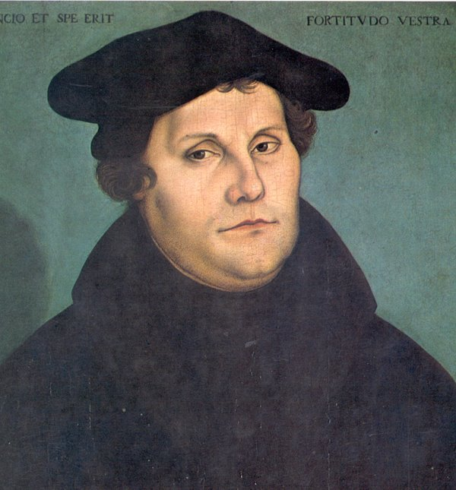

All Christians fall into three categories:
- Roman Catholic
- Eastern Orthodox: Greek Orthodox, Russian, Orthodox, etc.
- Protestant: Churches that develop out of protests with the Roman Catholic Church

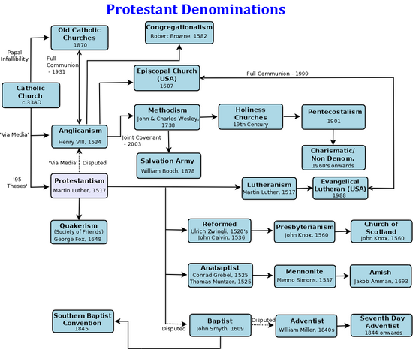

After nearly dying from a lightning strike, Luther became a monk and university professor. As he spent more and more time devoting his life to the Church, he grew dissatisfied:
- Complaint #1: People should have a personal relationship with God and not have to go through priests and the Pope.
- Complaint #2: It is this personal relationship with God, not good works that should determine whether you go to heaven.
- Complaint #3: some priests were illiterate and unfamiliar with the Bible, because so many priests died during the Bubonic Plague.
- Complaint #4: People should read the Bible, not in Latin, but in their own language
- Complaint #5: Bad Popes
- Renaissance popes like Alexander VI were corrupt and sinful: having mistresses and illegitimate children, orgies, misusing church money, and assassinating other men to become Pope, and waging war against Italian dukes and princes.
- Complaint #6: Selling Indulgences
  - This made Luther the most angry.
  - When you pay money for the priest to forgive your sins.
Luther wrote all his complaints about the Church in the 95 Theses. In 1517, he posted the 95 Theses on the door of his local church in Wittenberg, Germany.
Printing press and literacy:
- The printing press was invented by Johannes Gutenberg in 1439.
- Luther could publicize his 95 Theses and his German Bible;
- People read his words throughout Europe
- Because there was more material to read, people started to learn to read.

The results were:
- Luther is excommunicated by Pope Leo X during the Diet of Worms.
- He marries a former nun, Catherine.
- He starts the Lutheran Church.
- The Thirty Years War, fought between Lutheran and Catholic German princes.
  - It’s estimated that 25% of the German population died in battle, of starvation, or disease.
- The Catholic Church reacts with the Counter-Reformation.

In the Lutheran Church:
- There’s singing. Luther wrote hymns.
- The mass is not in Latin; it’s in the vernacular (German in Germany, Finnish in Finland, Danish in Denmark, English in the USA)
- There are two sacraments: baptism and Eucharist.
- You are encouraged to read the Bible.
- You should focus on a personal relationship with God, not good works.
- Lutheran pastors can be married

In 2014, there are over 60 million Lutherans worldwide, who mostly live in Germany, the Low Countries (the Netherlands and Luxemburg), and Scandinavia (Denmark, Norway, Sweden, Finland, and Iceland).
John Calvin and his ideas
John Calvin: Lived in Switzerland and during the 1500s, like Luther.

Calvin’s ideas influenced the Congregationalists (who used to be the Puritans), the Presbyterians in Scotland, and Unitarians. The architecture of Calvinist churches is much simpler than Catholic Churches. Calvin made Geneva, Switzerland into a theocracy.
Calvin’s unique idea: predestination
- Since God knows everything (He is omniscient), He already knows whether or not you’ll be a good person;
- The good people, called the Elect, are automatically going to heaven;
- The bad people, called the Reprobate, are automatically going to hell;
- The way you act proves to the community which group you’re part of.

Henry VIII and the Church of England

King Henry VIII of England
- Came to the throne at age 12;
- Forced to marry Katherine of Aragon, so that the English could make peace with Spain, then one of the most powerful countries in Europe;
- Katherine was older than him when they married; she was his dead brother’s wife.
- She gave birth to one child, a daughter Mary;
- Henry needed a son to take over the throne;
- There had never been a queen of England before.

Anne Boleyn
- Henry had an affair with Anne’s sister, Mary, and met Anne;
- Anne promised Henry she would give birth to a son;
- Henry asked the Pope to grant him an annulment from Katherine so he could marry Anne;
- The Pope said no.

Henry VII founds his own Church
- Henry declares his own church, the Church of England, in the Act of Supremacy (1534);
- This allows him to claim all the wealth of Church (monasteries, abbeys, etc.) and its tithes;
- Divorces Katherine;
- He marries Anne;
- Anne gives birth to a daughter, Elizabeth;
- Henry has Anne beheaded because he still has no male heir;
- Married Jane Seymour, whom he loved, but she died. She gave him a son, Edward, who died at age 16;
- Married Anne of Cleves, whom he divorced;
- Married Catherine Howard, whom he beheaded;
- Married Catherine Parr, who outlived him.

Church of England
- Almost same as the Roman Catholic Church
- Seven Sacraments
- No pope!!!!!!
- Priests can marry
- Also called the Anglican or Episcopal Church.

Queen Mary I
- First Queen of England;
- Was Catholic like her mother, and disagreed with the Church of England;
- Killed Protestants, by burning alive;
- Nicknamed Bloody Mary.

Queen Elizabeth I
- Ruled for 44 years;
- Never married, called the Virgin Queen, because she would lose power to her husband if she did;
- Was Queen during the Shakespeare’s time;
- Beat the Spanish Armada, the world’s most powerful navy;
- Declared religious tolerance:
  - Elizabeth was one of the first monarchs NOT to demand that the whole country be the same religion
  - Declared that she didn’t care if people were Catholic or Protestant, as long as they were loyal to the Queen and England

