Quiz date: Tuesday, December 13, 2014

Review Sheet for
First Quiz on Ideologies

- Name two famous, non-American feminists.
- What actions were taken by the WPSU, the major British women’s suffrage group?
- Define suffrage.
- What were some goals of the feminist movement of the 1960s and ‘70s?
- List three countries and when they gave women the right to vote.
- What is feminism?
- What is nationalism?
- What is fascism?
- Give three examples of fascist leaders.
- Give three example of communist leaders who are also totalitarian.
- What is democratic socialism?
- Name three capitalist countries.
- Name three communist countries, past or present.
- Name three country which are democratic socialist.
- What is Social Darwinism?
- What are two pieces of evidence that Social Darwinism and eugenics were once mainstream movements.
- What is imperialism?
- Name three countries that were once colonies and the country by which they were colonized, e.g. India was colonized by Great Britain.
- Name two events in the struggle for LGBTQ rights.

- Which statement would Social Darwinists most likely support?
- Stronger groups have the right to rule and control weaker groups.
- Political equality strengthens the effectiveness of government.
- Universal suffrage is a basic human right.
- Public education should be guaranteed to all members of a society.

22. Which statement would Social Darwinists most likely support?
- Universal suffrage is a basic human right.
- Political equality strengthens the effectiveness of government.
- Stronger groups have the right to rule and control weaker groups.
- Public education should be guaranteed to all members of a society.

"God hath power to create or destroy, make or unmake, at his pleasure; to give life or send death; to judge . . . and to be judged [by] none . . . And the like power have kings; . . ."

23. Which idea is described by this passage?
- theory of divine right
- enlightened despotism
- Social Darwinism
- constitutional monarchy

24. The theory of Social Darwinism was sometimes used to justify
- the establishment of communist governments in Asia
- Latin American revolutions in the early 19th century
- the independence movement in India
- European imperialism in the late 19th century

25. The 19th-century ideas of Social Darwinism and the “White Man’s Burden” were often used to justify
- isolationism
- appeasement
- imperialism
- disarmament

The White Man's Burden

Take up the White Man's burden–
Send forth the best ye breed–
Go bind your sons to exile
To serve your captives' need;
To wait, in heavy harness
On fluttered folk and wild–
Your new-caught, sullen peoples,
Half-devil and half-child.
— Rudyard Kipling, 1899

26. The message of this poem was used by many Europeans to justify
- industrialism
- feudalism
- imperialism
- fascism

27. Which statement about both the Bolshevik Revolution in Russia and the rise of fascism in Germany and Italy is accurate?
- Economic conditions led to political change.
- Industrialization hindered national development.
- Goals were achieved by peaceful means.
- Communist ideals fueled both movements.

28. The 19th-century term White Man's Burden" reflects the idea that
- Asians and Africans were equal to Europeans
- Asians and Africans would be grateful for European help
- imperialism was opposed by most Europeans
- Europeans had a responsibility to improve the lives of their colonial peoples

"All great nations . . . have desired to set their mark upon barbarian lands, and those who fail to participate in this great rivalry will play a pitiable role in time to come."

29. This quotation supports the concept of
- socialism
- human rights
- revolution
- imperialism

- French is spoken in Laos and Vietnam
- Spanish is spoken in the Philippines
- Dutch is spoken in Indonesia
- English is spoken in Malaysia and Singapore
30. The diversity of languages spoken in these Southeast Asian nations reflects the lasting legacy of
- socialism
- Asian nationalism
- traditionalism
- European colonization

31. One reason the Fascist governments of Benito Mussolini and Adolf Hitler came to power in Italy and Germany was that these nations
  - were threatened by the United States
  - supported civil liberties for all
  - failed to join the League of Nations
  - faced economic and political difficulties

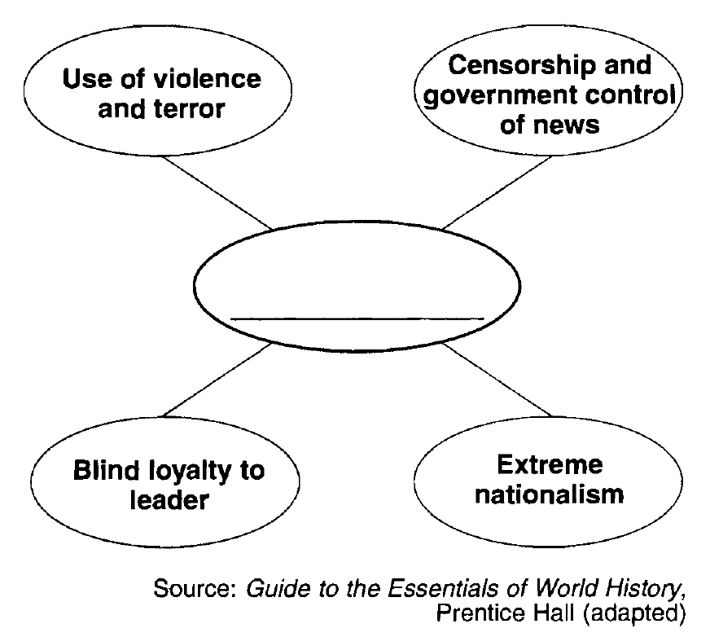
32. Which ideology best completes this graphic organizer?
  - socialism
  - democracy
  - capitalism
  - fascism

"Cavour Provokes War Against Austria"
"Mazzini Establishes Young Italy"
"Poles Fail in Revolt Against Russian"
33. These headlines best reflect the concept of
- nationalism
- isolationism
- imperialism
- totalitarianism

"I offer neither pay, nor quarters, nor provisions; I offer hunger, thirst, forced marches, battles, and death. Let him who loves his country in his heart, and not with his lips only, follow me."
— Giuseppe Garibaldi
34. Which concept is expressed by Garibaldi in this statement?
- scarcity
- nationalism
- humanism
- empathy

35. Nationalism is best defined as
- the achievement of world peace and global understanding
- the desire to take over other societies by force
- a method of solving basic economic problems of the society
- the loyalty of a people to their values, traditions, and a geographic region

36. The unification of Italy and the unification of Germany show that
- socialism was an effective way of organizing the economy
- colonialism could be used to spread European civilization
- nationalism could be used to consolidate political interests
- interdependence was a significant obstacle to waging war

37. The unification of Italy and the unification of Germany show that
  - socialism was an effective way of organizing the economy
  - nationalism could be used to consolidate political interests
  - colonialism could be used to spread European civilization
  - interdependence was a significant obstacle to waging war

- Appointment of Otto von Bismarck as Chancellor
- Austro-Prussian War, 1866
- Franco-Prussian War, 1870–1871
38. These events led directly to
- .the unification of Germany
- foreign rule in Italy
- the rebellion of the Sepoys
- an alliance between Serbs and Russians
39. The unification of Germany under Otto von Bismarck demonstrates the
  - influence of Marxist ideology
  - impact of nationalism
  - force of civil disobedience
  - power of democratic ideal

40. One political objective of both Otto von Bismarck and Giuseppe Garibaldi was to
  - overthrow divine right monarchies
  - unify their nations
  - establish communist systems
  - form an alliance with Great Britain

I. _________________________________
A. Unification of Italy
B. Formation of the Indian National Congress
C. Founding of the Muslim League
D. Breakup of Austria-Hungary

41. Which heading best completes the partial outline above?
  - Tensions of the Cold War
  - Effects of Nationalism
  - Causes of World War II
  - Results of Economic Revolutions

42. Which individual is associated with the phrase blood and iron as related to the unification of Germany?
- Otto von Bismarck
- Giuseppe Garibaldi
- Kaiser Wilhelm II
- Count Camillo di Cavour

"To him who wishes to follow me, I offer hardships, hunger, thirst and all the perils of war."
— Garibaldi's Memoirs
43. This quotation from Garibaldi is most closely associated with Italian
  - exploration
  - nationalism
  - imperialism
  - neutrality

44. A common element in the movements for German unification, Italian unification, and Indian independence was the
  - support of the Catholic Church
  - strength of nationalist leaders
  - mediation of the League of Nations
  - existence of democratic institutions

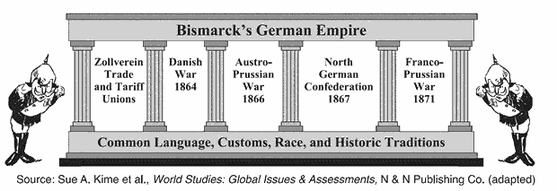
45. All the elements identified in the illustration contributed to German
  - interdependence
  - unification
  - imperialism
  - apathy

46. Which 19th century ideology led to the unification of Germany and of Italy and to the eventual breakup of Austria-Hungary and of the Ottoman Empire?
- imperialism
- nationalism
- liberalism
- socialism

Not by democracy or liberal standards will our goal be achieved but by blood and iron. Then we will be successful, no nation is born without the traumatic experience of war.
--Otto von Bismarck
47. This statement was used to justify a policy of
  - ethnocentrism
  - militarism
  - containment
  - appeasement

48. Which type of political system did V. I. Lenin, Adolf Hitler, and Benito Mussolini establish in their countries?
  - constitutional monarchy
  - totalitarianism
  - representative democracy
  - theocracy

49. Which basic belief characterized the totalitarian governments of Benito Mussolini and Saddam Hussein?
  - Nations must have written constitutions and free elections.
  - All religions are accepted.
  - The needs of the state are more important than individual rights.
  - Representatives of the people make the laws

50. In the 1920s and 1930s, the rise of totalitarian governments in Germany, Italy, and Spain was largely the result of
  - the success of the Communists in establishing a command economy in the Soviet Union
  - severe economic and social problems that arose in Europe after World War I
  - the active support of the United States
  - movements demanding the return of the old monarchies

