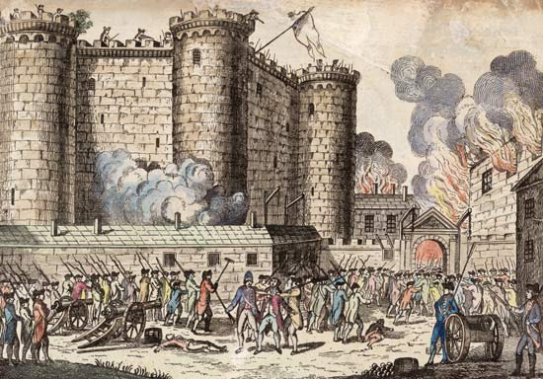

the second stage of
The French Revolution

Collins & Liu | Global History III | October 2016

What is the Third Estate? by Abbé Sieyes (1789)
Qu'est-ce que le tiers-état?

If the [nobility] should be abolished, the nation would be nothing less, but something more.

Therefore, what is the Third Estate? Everything; but an everything [that is] shackled and oppressed.

What would it be without the [nobility]? Everything, but an everything free and flourishing.

Nothing can succeed without it, everything would be infinitely better without the others.

The Third Estate embraces then all that which belongs to the nation; and all that which is not the Third Estate, cannot be regarded as being of the nation.

What is the Third Estate? It is the whole.

QUESTIONS
- What is the Third Estate?

- What would happen if the nobility was abolished?

Declaration of the Rights of Man and Citizen (1789)
Déclaration des droits de l'Homme et du Citoyen
Approved by the National Assembly of France, August 26, 1789
The representatives of the French people, organized as a National Assembly, believing that the ignorance, neglect, or contempt of the rights of man are the sole cause of public calamities and of the corruption of governments, have determined to set forth in a solemn declaration the natural, unalienable, and sacred rights of man . . . Therefore the National Assembly recognizes and proclaims, in the presence and under the auspices of the Supreme Being, the following rights of man and of the citizen:
Articles:
A. Men are born and remain free and equal in rights. Social distinctions [are abolished].
B. . . the natural rights of man are liberty, property, security, and resistance to oppression.
C. The principle of all sovereignty [power] resides essentially in the nation. No individual may exercise any authority which does not proceed directly from the [people].
D. Law is the expression of the general will. Every citizen has a right to participate personally, or through his representative, in [making laws]. All citizens [are] equal in the eyes of the law.
E. As all persons are held innocent until they shall have been declared guilty, if arrest shall be deemed indispensable, all harshness not essential to the securing of the prisoner's person shall be severely repressed by law.
F. The free communication of ideas and opinions is one of the most precious of the rights of man.
G. [Taxes are] essential for the maintenance of the [cost of government]. This should be equitably distributed among all the citizens in proportion to their means.
QUESTIONS
- Which philosopher had the greatest influence on this document? And which of his concepts do you see reflected?

- Who wrote this document? And on whose behalf?

- Please put all the articles (A-G) above into your own words.

Declaration of the Rights of Woman and Female Citizen (1791) by Olympe de Gouges
Déclaration des droits de la femme et de la citoyenne

[A] Man, are you capable of being just? It is a woman who poses the question; you will not deprive her of that right at least. Tell me, what gives you sovereign empire to oppress my sex? Your strength? Your talents?

[B] Man alone . . .he wants to command as a tyrant a sex which is in full possession of its intellectual faculties; he pretends to enjoy the Revolution and to claim his rights to equality.

[C] Mothers, daughters, sisters [and] representatives of the nation demand to be constituted into a national assembly. Believing that ignorance, omission, or scorn for the rights of woman are the only causes of public calamities and of the corruption of governments, [the women] have resolved to set forth a solemn declaration the natural, inalienable, and sacred rights of woman . . .

[D] Woman is born free and lives equal to man in her rights. Social distinctions [are abolished].

[E] The law must be the expression of the general will; all female and male citizens must contribute either personally or through their representatives to [making laws]; male and female citizens [are] equal in the eyes of the law.

QUESTIONS

- To what does de Gouges compare men (think of Hobbes) in part B? Why?

- What does de Gouges demand?

- Quote three similarities with the Declaration of the Rights of Man and Citizen?

- Do you think these similarities are intentional? Why would she use this parallel construction?

- To what hypocrisy is de Gouges trying to draw attention?

- How do you think the leaders of the revolution reacted to this document?

